Dear Editor,

Thank you very much for your letter and the comments from the reviewers about our paper submitted to the 2022 3rd Information Communication Technologies Conference (T42). I would like to thank the associate editor and the reviewers for their efforts on this paper. After carefully studying the reviewers’ comments and your advice, we have made corresponding changes to the paper. The manuscript submitted here is our revised manuscript with a new line and page number in the text. The revised portions are listed below. We also respond point by point to the reviewer’s comments in the following.

Hope these will make it more acceptable for publication.

**The following large modifications were made to the paper:**

1. To illustrate the performance of the STDFRFT algorithm, we have added the simulation of the convergence in subsection IV-B [page 4, column 1]. Specific convergence is shown in Fig. 3.
2. According to the comments of the reviewer, in order to better illustrate the advantages of the STDFRFT algorithm, we have compared STDFRFT with other methods in subsection IV-A [page 4, column 1] Specific comparisons are shown in Table 1.
3. In order to further illustrate the effectiveness, based on the recommendation of the reviewer, we have also provided the experiment of feature recognition of incomplete fingerprints in subsection IV-D [page 5, column 1]. Specific results are shown in Fig. 8.
4. Based on the reviewers’ comments, we have added some recent references and revised the format of the references.

Note: The language added and modified in the paper is marked in red font.

**Below are our responses to editorial suggestions and peer-to-peer reviewers' comments.**

**Response to Editor**

After peer review, your paper needs major revision before acceptance. Please kindly referring the attached comments to improve your paper. When you submit the revised paper, please also highlight the revised part in the manuscript and send it back within 3 working days. The notification will be sent you once the paper is acceptance.

**Response:** First of all, thank you very much for your comment. At the same time, we have carefully considered the comments and have revised the manuscript accordingly. In particular, we have added the simulation of the convergence in subsection IV-B [page 4, column 1]. In addition, we have compared STDFRFT with other methods to supplement Table 1 in subsection IV-A [page 4, column 1]. To further confirm the effectiveness, we have simulated the incomplete fingerprint signal and the features are identified using the STDFRFT algorithm in subsection IV-D [page 5, column 1]. Furthermore, we have cited some recent references ([2,3,4,8,10,11]). For clarity, we have highlighted the revised part in red font. Thanks again.

**Response to Reviewer**

Thank you very much for your valuable comments and suggestions. After carefully studying your suggestions, we have made corresponding changes to the paper.

**Comments:**

1. Discuss about the convergence of the model.

**Response:** Thank you for your significant comments. Based on your suggestions, we have verified the convergence of the STDFRFT algorithm in subsection IV-B [page 4, column 1]. Specifically, we have discussed the minimum number of iterations of the STDFRFT algorithm to detect all significant frequencies successfully. The fractional domain sparse random signals are still considered. And the sparsityof the signals are taken to be. The signal size is 65536, whereis equal to (256,256), (512,128), and (1024,64) respectively. In addition, the signals are added with complex Gaussian white noise with SNR = 34.1541dB. Fig. 3 shows the results of the simulation. It is not difficult to obtain that the STDFRFT algorithm is convergent. Moreover, the number of iterations increases with the increase of sparsity and.



Fig. 3 Number of iterations of STDFRFT algorithm vs. sparsity of signal.

**Comments:**

1. Compare the results from the literature to see how they could fill the gap (table 1 is not enough), we need to see several criteria using several existing methods.

**Response:** Thank you for your comments. We have supplemented Table 1 in subsection IV-A [page 4, column 1]. There is no specifically fast algorithm for 2D DFRFT. Therefore, we replace the definition (direct method) in the traditional decomposition method with the fast algorithms ([7,10,11]) for 1D DFRFT. And our method is optimal in every respect. The reasons for choosing [7,10, 11] are as follows:

Many definitions of DFRFT have been proposed and can be classified as sampled DFRFT, eigen-decomposition DFRFT, and linearly weighted DFRFT. First, the linearly weighted DFRFT is used rarely since it cannot approximate the continuous FRFT. Second, the eigen-decomposition DFRFT cannot be written in closed form and has a high runtime complex. The method in [11] is the latest and fastest algorithm for eigen-decomposition DFRFT. Finally, for applications that do not require rotational additivity, the sampled DFRFT is the favorite. And the most commonly used algorithm for sampled DFRFT is proposed by Ozaktas [10] and Pei[7]. Thus, our method is compared with the decomposing and [7,10, 11], the direct method.

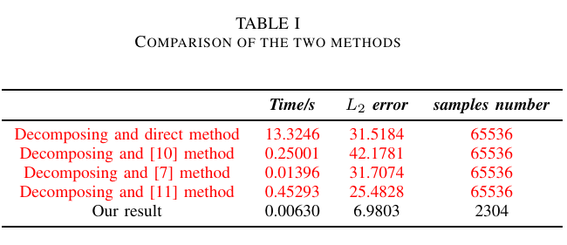

**Comments:**

1. What about fingerprints with error or incomplete data, how does this proposed model work?

**Response:** Thank you for your valuable suggestions. Based on your suggestions, we have simulated the incomplete fingerprint signal as shown in Fig. 6(b). The fingerprint features are identified by the STDFRFT method, and the result is displayed in Fig.8(b). By comparing with Fig. 8(a), we can know that our algorithm can extract the main features even for incomplete fingerprints.

|  |  |
| --- | --- |
|  |  |
| (a) Fingerprint image. | (b) Incomplete fingerprint image. |

Fig. 6 Fingerprint images after preprocessing.

|  |  |
| --- | --- |
|  |  |
| (a) Our result for Fig. 6(a) | (b) Our result for Fig. 6(b) |

Fig. 8 Recognition result of fingerprints in fractional domain by our method.

**Comments:**

1. And, reference lists are mostly old!

**Response:** According to your suggestion, we have cited some recent references ([2,3,4,8,10,11]) in the introduction and subsection IV-A. Thanks.

Thanks again to you and the anonymous referees for the helpful and valuable comments and suggestions that have greatly improved the clarity and quality of this manuscript. I hope the revised manuscript will be satisfactory.

Sincerely yours

Jun Yang